|  |
| --- |
| **Program Name – Computer Engineering**  **Program Code – CO-5-I**  **Course Name – Client Side Scripting Language**  **Course Code – 22519**  **Project Title**  **“Book Listing”**  **Academic Year 2019-20** |

**Program Name - Computer Engineering**

**Program Code – CO-5-I**

**Course Name –Client Side Scripting Language**

**Course Code – 22519**

**Project Title**

**“Book Listing.”**

|  |  |  |  |  |
| --- | --- | --- | --- | --- |
| **Sr. No.** | **Name of Student** | **Roll No.** | **Enrollment No.** | **Exam Seat No.** |
| 1 | Vaishnavi Patil | 301 | 1600170094 |  |
| 2 | Lalit Amrutkar | 312 | 1700170014 |  |
| 3 | Nivedita Mali | 322 | 1700170033 |  |
| 4 | Swarnim Jain | 336 | 1700170053 |  |



**MAHARASHTRA STATE BOARD OF TECHNICAL EDUCATION**

**CERTIFICATE**

This is to certify that Mr./Ms1600170096,1700170014,1700170033,1700170053 Roll No**. 301,312,322,336** of **Fifth** Semester of Diploma in **Computer Engineering** of Institute **Government Polytechnic, Dhule (0017)** has completed the Micro Project satisfactorily in the Subject**Client Side Scripting Language(22519)** for the Academic Year 2019-20 as prescribed in the curriculum.

Place: Dhule

Enrollment No:1600170094,1700170014,1700170033,1700170053

Date: Exam Seat No:

Subject Teacher Head of the Department Principal

**Acknowledgment**

We express our sincere gratitude to our college Government polytechnic, Dhule for providing us an opportunity to undertake and complete such an interesting project report.

We are very thankful to our respected faculty Mr.S.P.Arutwar& Miss M.H.Rajput for the confidence he/she had on us regarding this project. We are very much obliged to our respected principal, Dr.R.G.Wadekar for inspiring and motivating us to bring out a successful project.

We are very grateful to our respected faculty Mr.S.P.Arutwar &Miss.M.H.Rajputwho was our backbone and our guide throughout this project. Without his assistance we couldn’t have completed this project within a short period of a time.

It would be really very unfair without mention of our friends and families for the immense love and moral support they have given is truly immeasurable.

**Abstraction**

In this project we have created a Book listing webpage. In this we have used all the functions of client side scripting language. We have created this project to improve to store the information and records to webpage.

In this we have three text fields that gets the name of book . author of book and the price of the book. After that we have one button “Add” Which adds our book information in to the web-browser cookie . after adding it displays the information in the form of table on bottomof web page . also in our web page the table have a delete option to delete the record from the coolie.

**Coding of the project**

<!DOCTYPE html>

<html>

<head>

<title>Book List</title>

</head>

<body background="book.jpg">

<font color="white">

<div class="container">

    <hr>

<h1><center>Add Book</center></h1>

        <hr>

<form action="" id="book-form">

<center>

<label for="title">Title</label>

<input type="text" id="title">

<br><br>

<label for="author">Author</label>

<input type="text" id="author">

<br><br>

<label for="price">Price</label>

<input type="text" id="Price">

<br><br>

<input type="submit" value="Add" id="submit" >

</center>

</form>

<hr>

<center>

<table cellspacing=10>

<thead >

<tr>

<th>Book Title</th>

<th>Author</th>

<th>Price</th>

<th></th>

</tr>

</thead>

<tbody id="book-list"></tbody>

</table>

</center>

</div>

<script >

class Book

{

constructor(title, author, price)

{

this.title = title;

this.author = author;

this.price = price;

}

}

class UI

{

addBookToList(book)

{

const list = document.getElementById('book-list');

const row = document.createElement('tr');

row.innerHTML = `

<td>${book.title}</td>

<td>${book.author}</td>

<td>${book.price}</td>

<td><a href="#" class="delete">X</a></td>

`;

list.appendChild(row);

}

deleteBook(target)

{

if (target.className === 'delete')

{

target.parentElement.parentElement.remove();

}

}

clearFields()

{

document.getElementById('title').value = '';

document.getElementById('author').value = '';

document.getElementById('Price').value = '';

}

}

class LocalStorage

{

static getBooks()

{

let books;

if (localStorage.getItem('books') === null)

{

books = [];

}

else

{

books = JSON.parse(localStorage.getItem('books'));

}

return books;

}

static displayBooks()

{

const books = LocalStorage.getBooks();

books.forEach(function (book)

{

const ui = new UI();

ui.addBookToList(book);

});

}

static addBook(book)

{

const books = LocalStorage.getBooks();

books.push(book);

localStorage.setItem('books', JSON.stringify(books));

}

static removeBooks(price)

{

const books = LocalStorage.getBooks();

books.forEach(function (book, index)

{

if (book.price === price)

{

books.splice(index, 1);

}

});

localStorage.setItem('books', JSON.stringify(books));

}

}

document. addEventListener('DOMContentLoaded', LocalStorage.displayBooks);

// Event listeners

document.getElementById('book-form').addEventListener('submit', function (e)

{

const title = document.getElementById('title').value,

author = document.getElementById('author').value,

price = document.getElementById('Price').value;

// Instantiate a new book

const book = new Book(title, author, price);

const ui = new UI();

if (title === '' || author === '' || price === '')

{

alert("Please fill in all feilds");

}

else

{

ui.addBookToList(book);

// Adds the book to storage.

LocalStorage.addBook(book);

alert("Success! Book added!");

ui.clearFields();

}

e.preventDefault();

});

document.getElementById('book-list').addEventListener('click', function (e)

{

const ui = new UI();

ui.deleteBook(e.target);

LocalStorage.removeBooks(e.target.parentElement.previousElementSibling.textContent);

alert("Book removed!");

e.preventDefault();

});

</script>

</font>

</body>

</html>

Output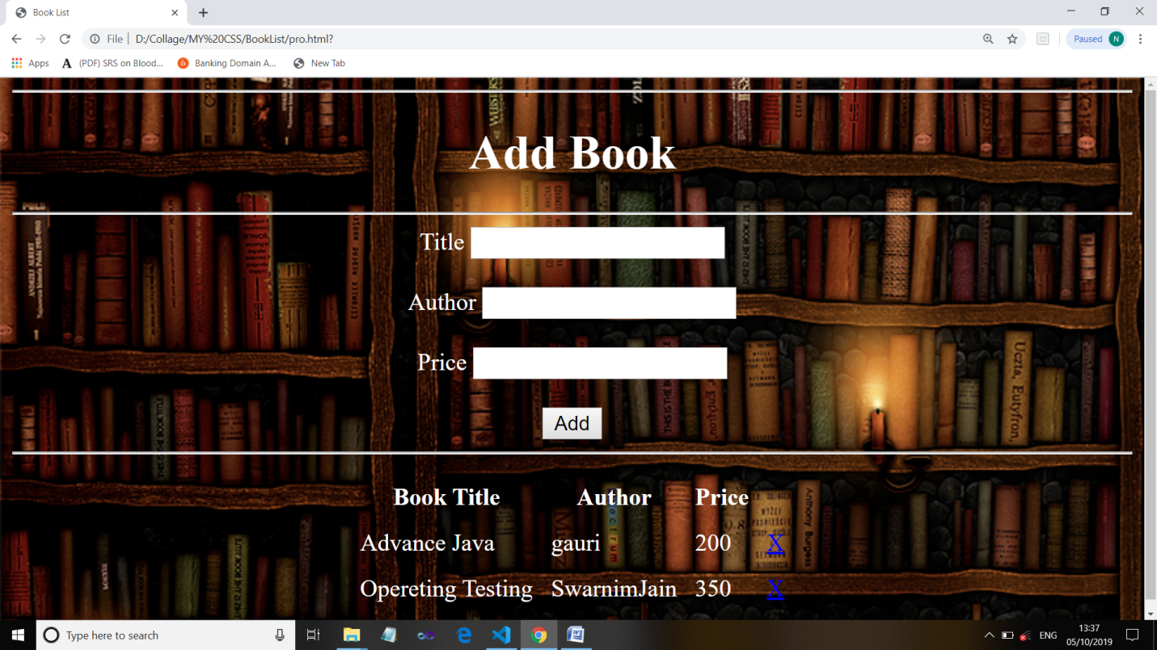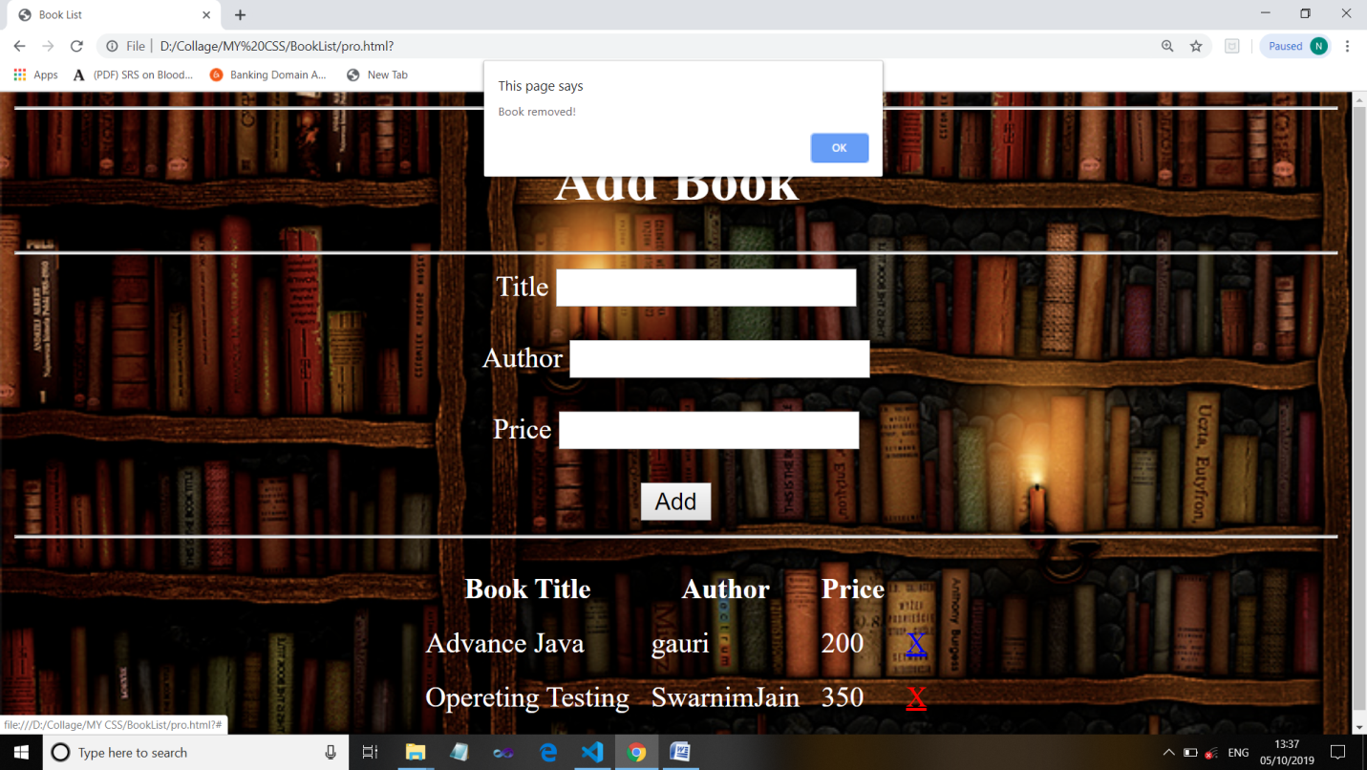

**EVALUATION SHEET FOR MICRO PROJECT**

**(Academic Year: 2019-20)**

**Name of the Student: Roll No: 301,312,322,336**

**Course: Client Side Scripting Language(22519) Course Code: CO5I**

**Title of the Project: “Book Listing”**

**Cos addressed by Micro Project:**

1. Create interactive web pages using program flow control structure.
2. Implements function in java script
3. Create event based web forms using java script.

**Comments/suggestions about teamwork/leadership/interpersonal communications (if any):**

|  |  |  |  |  |
| --- | --- | --- | --- | --- |
| **Roll No** | **Student Name** | **Marks out of 06 for performance in group activity (D5 Column 08)** | **Marks out of 04 for performance in oral or presentation (D5 Column 09)** | **Total out of 10** |
| 301 | Vaishvavi Patil |  |  |  |
| 312 | Lalit Amrutkar |  |  |  |
| 322 | Nivedita Mali |  |  |  |
| 336 | Swarnim Jain |  |  |  |